**Fielding 2.0 - Alias**

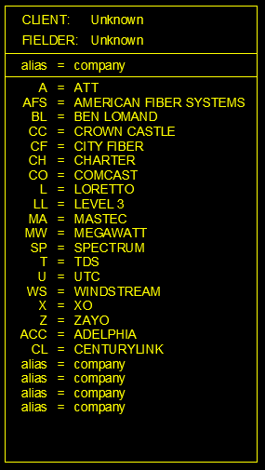

When you open a new job, you should find something similar to the above image.

Fill out the client’s name if it is “Unknown” and your name or initials.

This is an ever-evolving list of Company Aliases. Say you find a new company named Apollo Fiber and don’t want to type that every time they have an attachment on a pole. To make this easier you can select one of the “alias = company” blocks, change “company” to “apollo fiber”, and change “alias” to what you want to use. You can use most anything: “af”, “ap”, “apf”, etc. Whatever you enter into the fields will be converted to uppercase when it is processed in the office. Any new aliases will be added to the main list so they will be already there in future jobs.